Detailed operation procedures are shown as follows:

***1. Download the full zip file from the GitHub site.***

***2. Unzip the master file named “Pure-shift-2DJ-DOSY-main”.***

***3. Open the Matlab main function.***

*For example, the main function named “Main_Fig2” is adopted to obtain the desired 3D pure shift DOSY for three amino acid components, and to generate the Figure 2 shown in the manuscript. Similarly, the main function named “Main_inh_Fig3” is adopted to generate the Figure 3. It should be noted that the code parameters need to be well adjusted for different samples and raw data.*

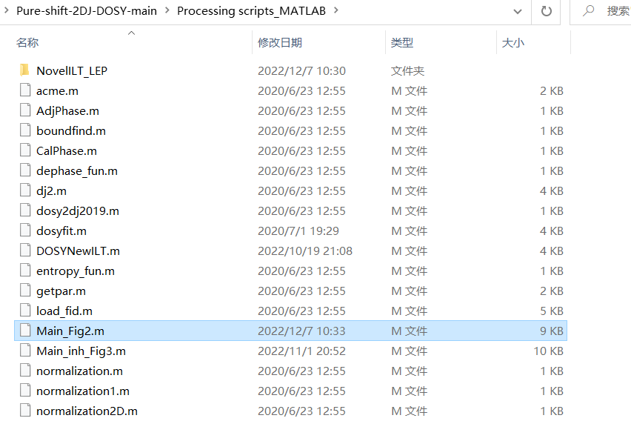

***4. Paste the right path of the raw data into the script.***

*For Figure 2 and 3, the suitable parameters have been well set.*

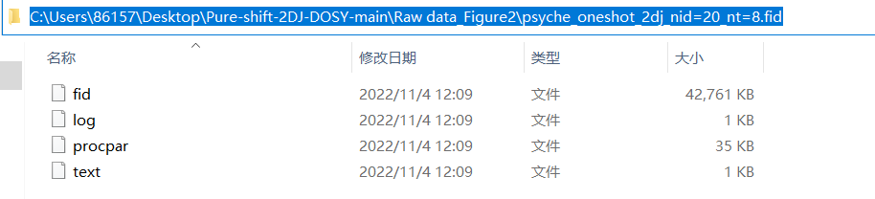

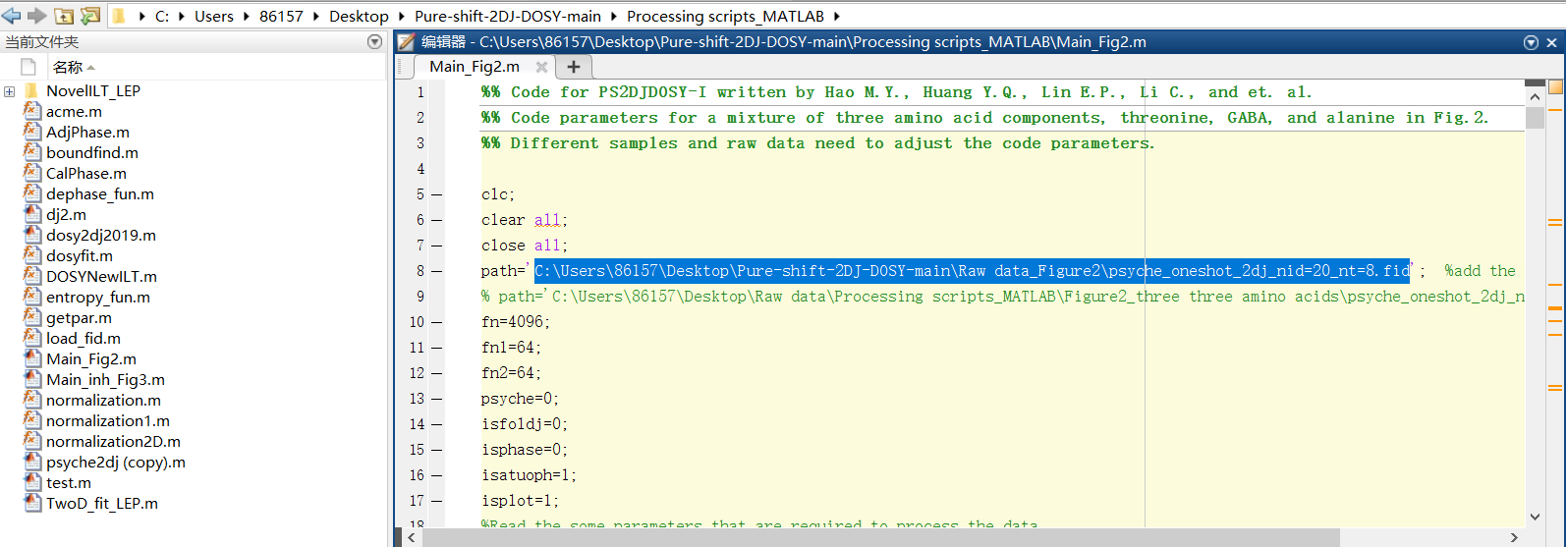

***5. Run the function.***

